**EXPERIMENT : 1 LED CHASER**

**DIAGRAM:-**

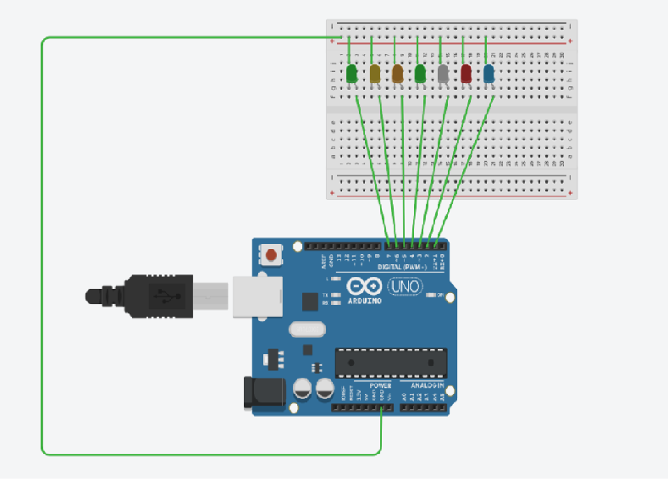

**THEORY:**

**CONCEPT USED- The concept of the following experiment is state as,the seven led’s will blink one after another. There should not be any time duration between the off of previous light and the on of the next consecutive light.**

**LEARNING AND OBSERVATIONS-**

* **There is no need of any resistor while working we led on ardiuno to reduce power supply.**
* **We learn how to code in ardiuno.**
* **We learn about the proper use of delay function during coding.**

**PROBLEMS AND TROUBLESHOOTING –**

* **When we used the delay function in the code after making led low it generates the time gap between the off of previous led and on off on next consecutive led .So, we removed the delay gap after making led low.**
* **While during connections it is important to do all connection in a sequence manner otherwise for loop will not be used while during program.**

**PRECAUTIONS -**

* **Wiring should be done properly,neatly.**
* **Do not use excess wires try to reduce number of wires used.**
* **Program should be written without giving delay between last led off and next led on.**

**LEARNING OUTCOMES –**

**We learn to code and how to make circuit using ardiuno.**